**DAILY ONLINE ACTIVITIES SUMMARY**

|  |  |  |  |  |  |  |  |
| --- | --- | --- | --- | --- | --- | --- | --- |
| **Date:** | **09-06-2020** | | | | **Name:** | **B.A.SOHANKUMAR** | |
| **Sem & Sec** | **4TH SEM A** | | | | **USN:** | **4AL18CS013** | |
| **Online Test Summary** | | | | | | | |
| **Subject** | | **----** | | | | | |
| **Max. Marks** | | **----** | | **Score** | | **----** | |
| **Certification Course Summary** | | | | | | | |
| **Course** | **ARTIFICIAL INTELLIGENCE IN PYTHON** | | | | | | |
| **Certificate Provider** | | | **GLA** | **Duration** | | | **7 HOURS** |
| **Coding Challenges** | | | | | | | |
| **Problem Statement:1:Write a C program to rotate the matrix by K times.** | | | | | | | |
| **Status: EXECUTED** | | | | | | | |
| **Uploaded the report in Github** | | | | **YES** | | | |
| **If yes Repository name** | | | | **LOCKDOWN CODING** | | | |
| **Uploaded the report in slack** | | | | **YES** | | | |

**ONLINE CERTIFICATION COURSE:**

Course: Artificial intelligence in python

Today I have opted this new course.This course is totally of 7 hours and it contains 12 modules.Whole certification course is thought by prof.Mukesh Rao through virtual classroom.Today the modules I have completed are History behind Neural Networks,Relationship between Biological Neuron and Artificial Neuron,Perceptron and Working Mechanism,Architecture of Artificial Neural Network,Types of Activation Functions,Softmax Function.

 

**CODING CHALLENGES DETAILS:**

1.Write a c program to rotate the matrix by K times.Rotate the matrix by K times means rotating the given NN matrix to the specified (K) number of times.

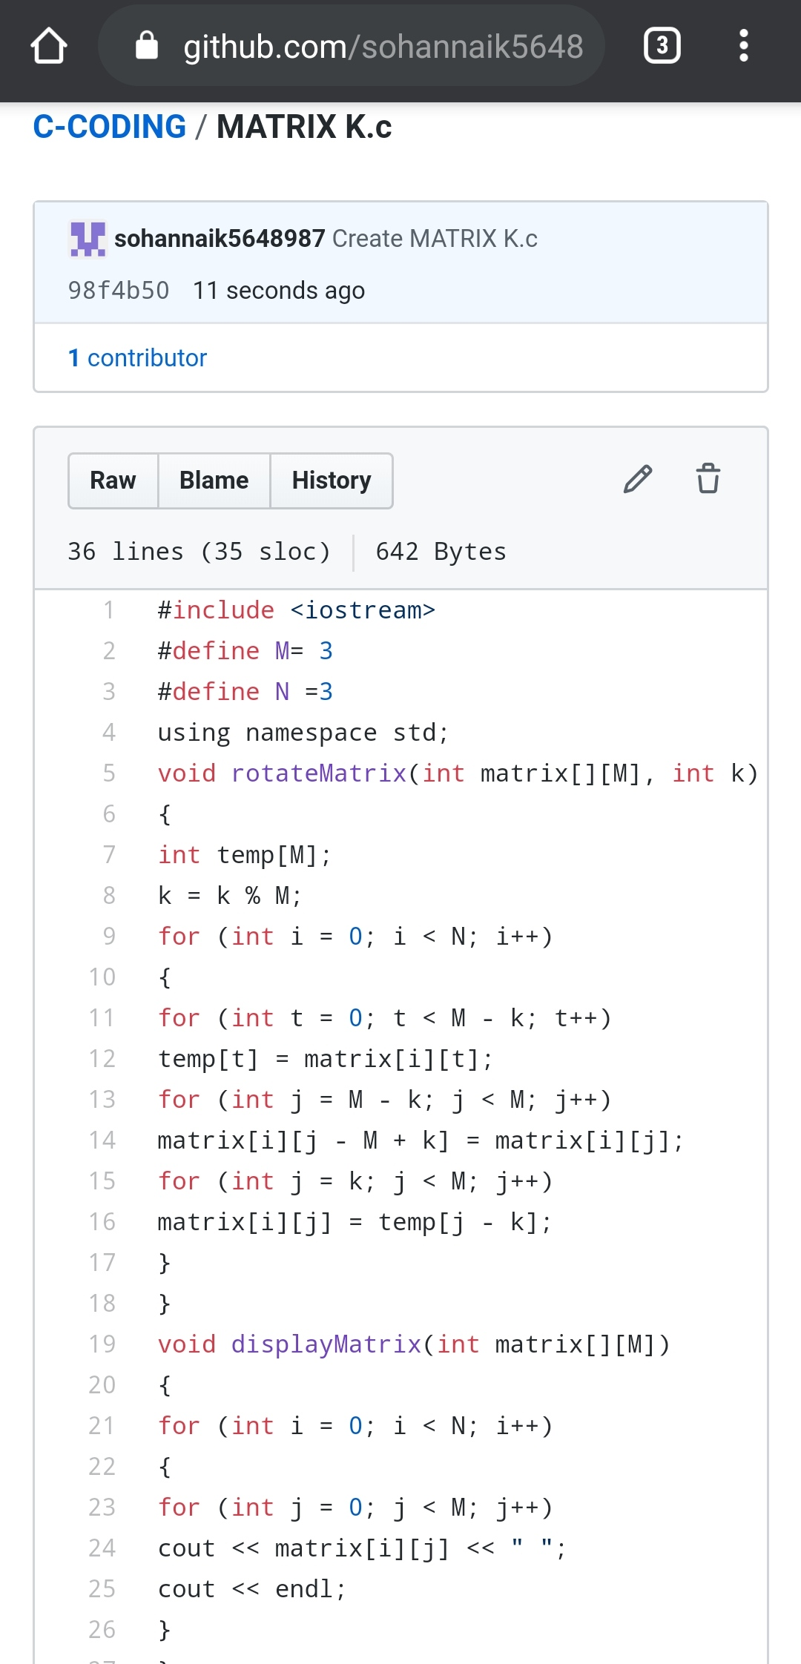

REPOSITORY LINK:https://github.com/sohannaik5648987/C-CODING